38. Custom Metadata Types - 19 July 2021

**Definition:** A Custom Metadata type is like a custom object and is the replacement of the List type Custom Settings.

* Like Custom Settings, Custom Metadata type is also stored in the Application Cache Level.
* The main advantage of Custom Metadata type is, when we deploy it from one environment into another, then it gets deployed along with it all existing records.
* To fetch the Custom Metadata Type records, we need to query it, but this SOQL can not be count in governor LIMITS.

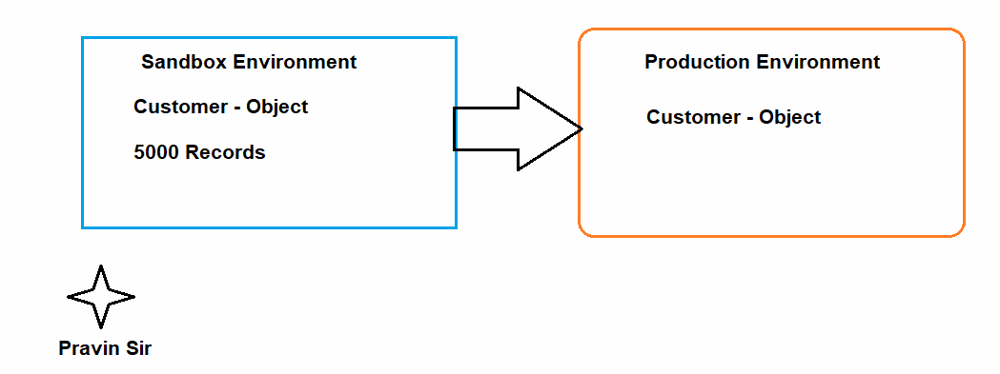

Setup 🡪 Quick Find Box 🡪 Custom Metadata Type 🡪 New

List<Country_Code__mdt> metaList = [select id,MasterLabel, Codes__c from Country_Code__mdt];

System.debug(metaList);

List<Country_Code__mdt> metaList = [select id,Name, Codes__c from Country_Code__mdt];

for(Country_Code__mdt objMeta : metaList){

System.debug('County='+objMeta.Name+' Code '+objMeta.Codes__c);

}

Difference between Custom Settings and Custom Metadata Type.

|  |  |
| --- | --- |
| Custom Settings | Custom Metadata Type |
| 1. Custom setting doesn’t need query. | Custom Metadata type need query to fetch the records. |
| 1. Custom Settings are easy to access. | Custom Metadata is easy to deploy. |
| 1. Custom Setting allow to set different data set for different users by Hierarchical Custom Setting Type. | Custom Metadata Type allows Validation Rules and Page-Layouts. |

QUIZE : When to use what?

1. Life Insurance need to store the data in a table this has to be frequently accessible and easy to access by the users?

Which to use: **Custom Object**, **Custom Settings** OR **Custom Metadata Type**

1. Life Insurance need to store the data in a table and there must be a tab in User Interface?

Which to use: **Custom Object**, **Custom Settings** OR **Custom Metadata Type**

1. Life Insurance need to store the data in a table this has to be access without using the query?

Which to use: **Custom Object**, **Custom Settings** OR **Custom Metadata Type**

1. Life Insurance need to store the data in a table and I need to use it in formula field of the custom object?

Which to use: **Custom Object**, **Custom Settings** OR **Custom Metadata Type**

1. Life Insurance need to store the data in a table and I should be able to get data on different users?

Which to use: **Custom Object**, **Custom Settings** OR **Custom Metadata Type**

1. Life Insurance need to store the data in a table this has to be frequently accessible and easy to access by the users and want to perform validation Rules also PageLayout?

Which to use: **Custom Object**, **Custom Settings** OR **Custom Metadata Type**